Installing Cyrillic Language Support on Mac OS X
The instructions on this web page will show you how to input Cyrillic characters on your Mac OS X computer. Mac OS X 10.4.2 (Tiger) also comes with a phonetic Russian keyboard. Phonetic means that typing the d key wil produce д, i = и, a = a, etc. Unfortunately earlier versions of OS X do not come standard with a phonetic Russian keyboard.
- Open the System Preferences. Under the apple on the far left of the top menu bar select "System Preferences".
- Click on the "International" icon, which should be in the top row.
- In the International preferences click on the "Input Menu" tab.
- Scroll down and select “Russian” as in the image below . This will give you the Russian standard keyboard. If you have Mac OS X 10.4.2 (Tiger) you will also have the option of choosing “Russian – Phonetic”. This will give you the phonetic keyboard, i.e. a = a, d = д, etc.

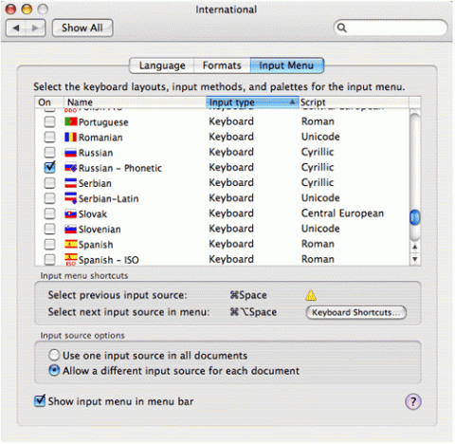
- Toward the bottom make sure that the following are both selected:
  - Allow a different input source for each document
  - Show input menu in menu bar
- Close the System Preferences
- At the top right of your menu bar, just to the left of the clock you should now see an American flag. Click on it and you will also see the Russian flag. To switch between input languages just click here and select the appropriate flag.
If you wish to learn the Russian standard keyboard layout you can right click on the following image to download it to your computer and print it out for ready reference.
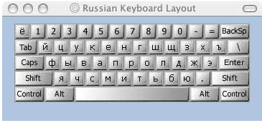
Tags:
ats
russian
cyrillic

